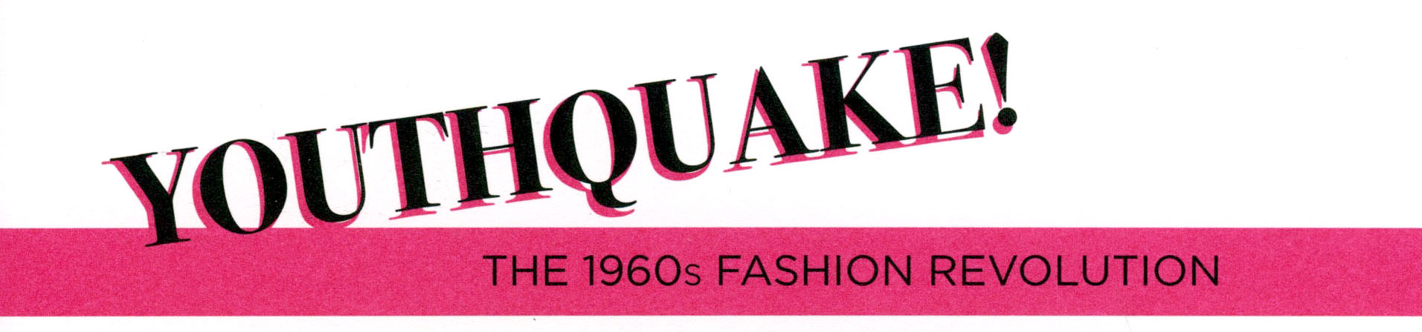

Gallery and Classroom Lesson Plan

Abstract: This lesson provides student visitors to the exhibition Youthquake!
The 1960s Fashion Revolution the opportunity to explore in depth how youth culture made an impact on fashion in the 1960s. Students will visit the exhibition, think critically about the objects on view, consider how youth culture of the 1960s makes an impact on fashion today, and create their own design for an iconic representation (to be drawn on a paper dress template) of today’s youth culture.

Grade/Level: High school seniors
Subject: Visual Arts
Time Required: 2 hours: 1 hour discussion and note-taking in museum gallery;
1 hour discussion and activity in classroom
Materials Required: In the gallery: notebook and pencil. In the classroom: color copies of the Dior and Twiggy photographs, and the Harry Gordon paper dress (see enlarged images at end of lesson plan), sketchpad, drawing medium (e.g. pencil, ink, marker, watercolor), and paper dress template (see image at the end of lesson plan).

Educational Standards: New York State Learning Standards for the Visual Arts, Standard 3.4.3:
- “Students analyze and interpret the ways in which political, cultural, social, religious, and psychological concepts and themes have been explored in visual art”

Lesson Objectives:
- Analyze and interpret how youth culture influenced fashion in the 1960s
- Learn about fashion history and draw comparisons to contemporary fashion
- Think critically about fashion

Lesson Overview: This lesson is designed to teach students how youth culture
of the 1960s revolutionized the world of fashion, and how the changes that occurred during the decade continue to influence fashion today. Students will actively seek out evidence of youth culture and creativity in the exhibition objects, working in pairs to discuss their findings. In the classroom, students will continue
to think critically about the impact of 1960s youth-driven fashion and culture on how we dress and shop today. Concepts that were considered revolutionary in the 1960s may seem normal to youth today, so the lesson will introduce students to “pre-Youthquake” fashion, contextualizing what they saw in the exhibition.

Lesson Plan, Gallery:

- 00:00 – 00:03 min.
  - Teacher introduces general concepts of the exhibition to the students at the entrance of the gallery (please refer to exhibition overview at end of lesson plan).

- 00:03 – 00:18 min
  - Group walks to view the Harry Gordon paper dress bearing Bob Dylan’s image. Have the class discuss the object itself and how it fits into the themes of the exhibition. Why do they think this object was chosen to represent the entire exhibition? What does “iconic” mean? Make sure the following points are covered: The dress is made of paper, the fact that it is a mini-dress, and it depicts the image of a popular musician –all aspects that refer to youth culture.

- 00:18 – 00:35 min.
  - Allow students to explore the gallery in pairs and select one object in the exhibition where they can clearly see the influence of youth culture of the 1960s. Ask them to take notes and list the elements of youth culture they see in it.
Every pair must select a different object.

- 00:35 – 00:45 min.
  - Pairs spend 10 min. discussing what they will present to the rest
of the class: Why did they choose the object? What specific, concrete elements show how youth culture influenced each object? What else did they notice / like / dislike about the exhibition?

- 00:45 – 00:60 min.
  - Students reconvene as a group to present their object choices and
give overall responses to the exhibition. Are there “popular” objects selected by the class? What objects were not selected, and why? Are there recurring themes or ideas that students mention as their reasons for their choices?
  - Instructor assesses that students understand the concept of the lesson plan as it relates to the exhibition. In which ways do they see the same “youth” elements from the 1960s in contemporary fashion? (e.g. the ubiquitous use of denim and jeans, mini-skirts and tunic dresses, resurgence of the “bohemian” look, etc.) Ask students to look at their own clothes. What elements of youth culture do they see in their clothing? Do they see any influence of the 1960s in their outfit today?

Lesson Plan, Classroom:

- 00:00 – 00:10 min.
  - As a class, review and discuss the main themes of the exhibition. Ask students to recall some of the elements of youth culture that defined fashion during the 1960s.
  - Discuss “pre-Youthquake” fashion and the couture industry before
the 1960s. Print and share the two images below with students
(see enlarged images at end of lesson plan). Lead a discussion on the differences between Dior’s “New Look” and Twiggy’s youthful “London Look.” Some talking points may include: silhouette and ideal body type (sloped shoulders, nipped waits, and full hips versus A-line, baby-doll silhouette, boyish figure); shift in hemline (full, formal skirt versus the mini); sartorial traditions lost (rejection of hats and gloves, replaced with girls’ tights and bold accessories); innovative materials (leather stilettos versus silver metallic, T-strap heels); difference in age and composure of the models (mature model versus young model); the “New Look” as a kind of fashion that makes young women look older, versus the “London Look” as a kind of fashion that makes young women look even younger; difference in the models’ stance and attitude in selling the “look”; Parisian couture versus boutique mass fashion.

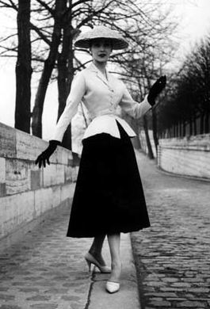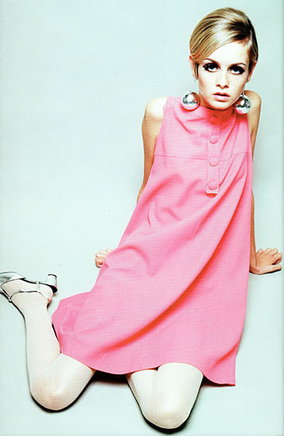

- 00:10 – 00:25 min.
  - Open up the discussion by asking students to think about how today’s youth culture influences contemporary fashion. Some talking points may include: young celebrity designers (e.g. The Row and Olsenboye by Mary-Kate and Ashley Olsen), actors/models (e.g. Hailee Steinfeld), musicians (e.g. Lady Gaga) and fashion bloggers (e.g. Tavi Gevinson).

- 00:25 – 00:35 min.
  - Ask students to recall the Bob Dylan paper dress that they saw
in the exhibition (see enlarged image at the end of lesson plan). Students will brainstorm and sketch designs for an iconic image (or representation) inspired by contemporary youth culture. Encourage them to think broadly about what evokes today’s youth culture for them (it could be a shape, a color, word(s), a face, etc.).

- 00:35 – 00:45 min.
  - Students select their strongest design and transfer it onto a full-page template of a paper dress, with both front and back views.

- 00:45 – 00:60 min.
  - Students present and discuss their designs. What was their inspiration? How does it reflect youth culture today? Where do they envision this design being marketed and sold?

Exhibition Overview: Youthquake! The 1960s Fashion Revolution explores the dramatic impact of young people on fashion during a decade of sweeping political, social, and cultural change. Vogue magazine identified the “eruption of the young in every field” as a “youthquake”—a term that came to describe the rise of young people as new fashion authorities.

The two leading youth subcultures of the 1960s were the Mods and the Hippies. Both groups challenged societal and sartorial traditions with daring, innovative, and provocative clothing. Prior to the 1960s, young people had little choice but to dress and shop like their parents.

London became the epicenter of youthquake fashion, where young designers
sold street-generated styles in small, independently-owned boutiques. Colorful, crowded, and pulsing with loud music, boutiques provided a unique shopping experience for an increasingly powerful consumer class. Designers experimented with nontraditional materials like plastic and metal, and Youthquake boutiques soon began to open in fashion centers such as New York and Paris.

Mass marketers and high fashion were also transformed by the Youthquake. Mass marketers sold clothing and accessories featuring the latest trends at affordable prices, and forward-thinking couturiers embraced the spirit of youthful exuberance. As the decade progressed, Mod style ceded to the rising influence of the Hippies and their eclectic mix of secondhand and ethnic-inspired dress. Despite the Hippies’ anti-consumerist stance, their style was quickly translated into high-fashion garments and accessories, and was co-opted by mass marketers.

Every aspect of fashion—who created it, how it was made, and who could participate in it—had changed by the end of the 1960s. In the wake of the youthquake, no single look or designer dominated, and no one fashion authority reigned. Regardless of which youth group was redefining fashion at the moment—the early 1960s Mods or the Hippies later in the decade—its styles were quickly appropriated by mass marketers and couturiers alike. By comparing designs from cutting-edge boutique and mass-market labels to high fashion ready-to-wear and couture, the exhibition attests to the ascendance of youth as the driving force in fashion.

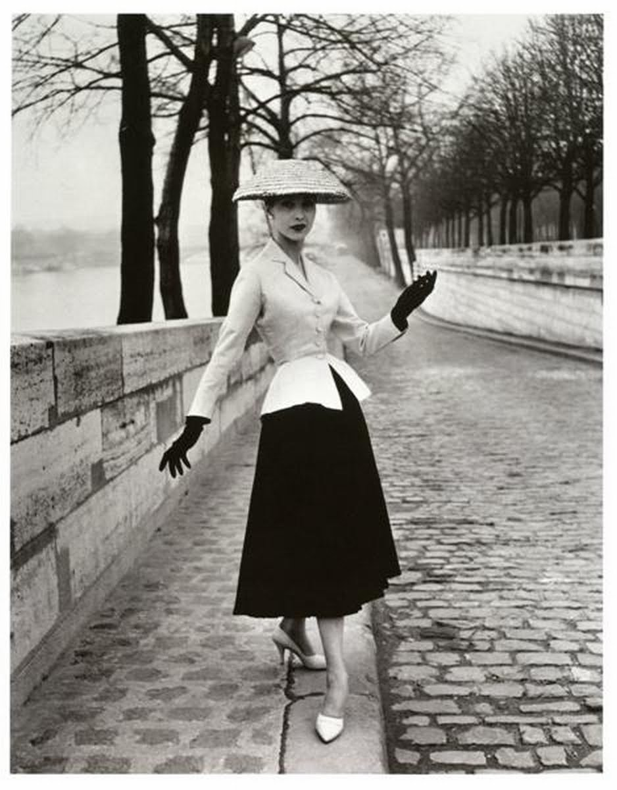 Reproduction of "Le Bar" (originally 1947) by Christian Dior, made for
the Victoria and Albert Museum, c. 1955. Modeled by Alla. Photograph by
Willy Maywald. © Assoc. Willy Maywald/ADAGP.
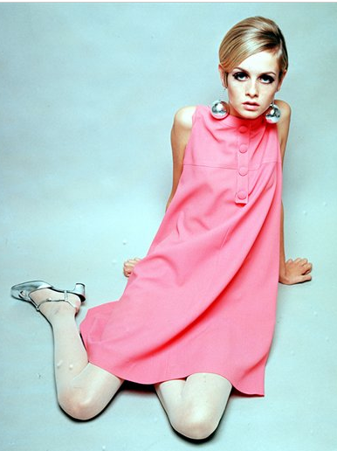
Twiggy, 1966. Photograph by Popperfoto/Getty Images.

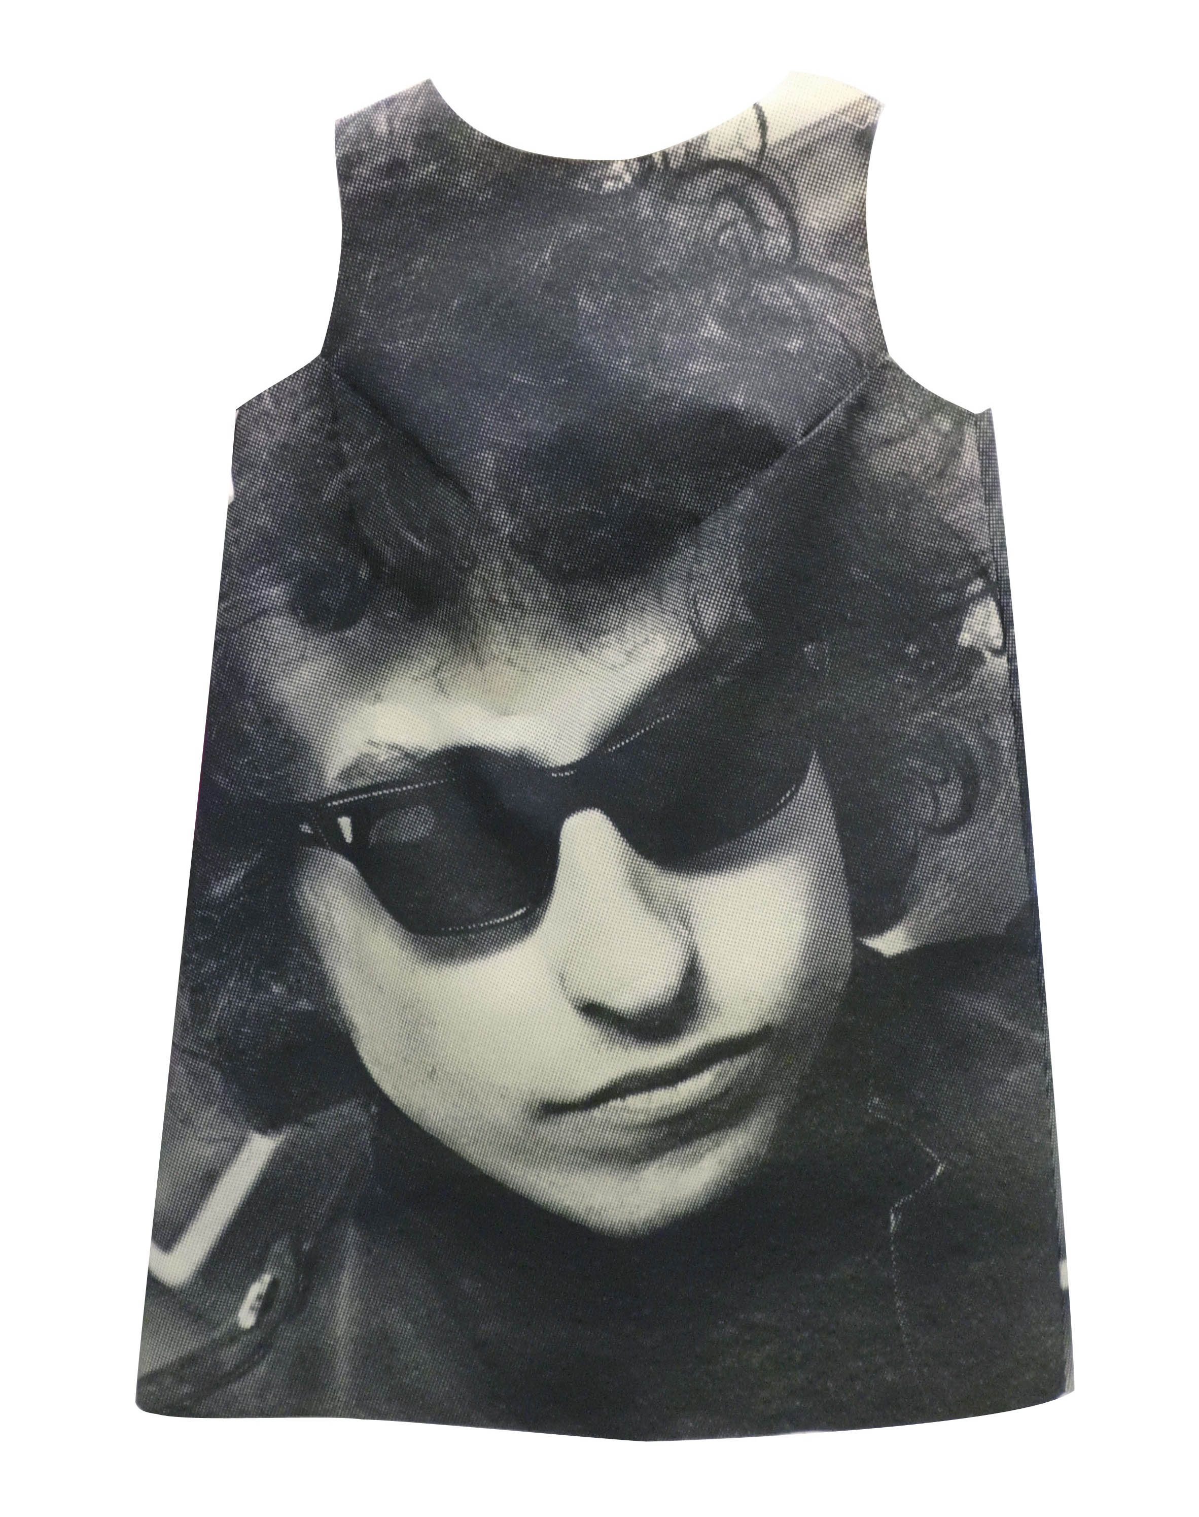 Harry Gordon, dress with printed image of Bob Dylan, paper, 1968.
The Museum at FIT; gift of Estelle Ellis.

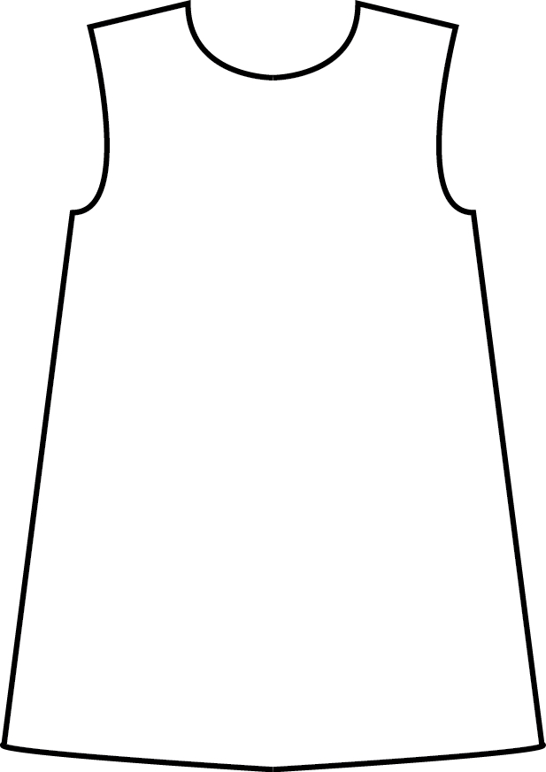

American Vogue identified the “eruption of the young in every field” as a “youthquake,” and the term came to describe the rise of young people as new fashion authorities

